1. [40] Use AGNES algorithm with Euclidean distance and single link to find the hierarchies of clusters in the following data set.

(a) Trace the algorithm up to the end of the first iteration of the main loop

Minimum = (B , A)

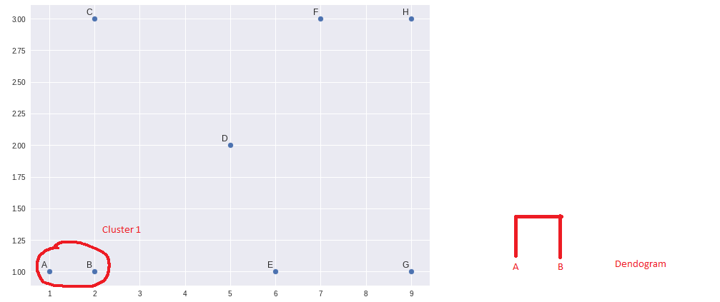

Recalculate Distance (Single Link):

MIN[distance(A,B), A)]

MIN[(A,A), (B,A)]

MIN[(0, 1)]

= 0

MIN[distance(A,B), B)]

MIN[(A,B) , (B,B)]

MIN(1, 0)

= 0

MIN[distance(A,B), C)]

MIN[(A,C), (B,C)]

MIN[(2.23, 2)]

= 2.23

MIN[distance(A,B), D)]

MIN[(A,D), (B,D)]

MIN[(4.12, 3.16)]

= 3.16

MIN[distance(A,B), E)]

MIN[(A,E), (B,E)]

MIN[(5, 4)]

= 4

MIN[distance(A,B), F)]

MIN[(A,F), (B,F)]

MIN[(6.32, 5.38)]

= 5.38

MIN[distance(A,B), G)]

MIN[(A,G), (B,G)]

MIN[(8, 7)]

= 7

MIN[distance(A,B), H)]

MIN[(A,H), (B,H)]

MIN[(8.24, 7.28)]

= 7.28

Updated Distance Matrix

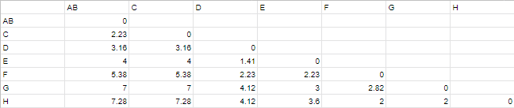

End of First Iteration

(b) Draw the points on a piece of paper, find all clusters that would be found by the algorithm (you do not have to show every step in the trace, but you should follow the algorithm), and draw the resulting Dendrogram

